Beer Name: TKK(Irish Red Ale)
Brew Date: Dec27'15
Batch Size: 10 gal
Target OG/◦P: 1.058
Amnt lb/kg Ingredient
15 # Pale
2 # Wheat
1.25 # Crystal 60-80
.65 # Cara malt
100 g Roasted barley
2 # Grated red potatoes
1 Tsp NaCl (mash)
1 tsp NaCl(sparge)
5 Tsp Sprchrg
Irish Moss
Nottingham Yeast

Qt oz/g Hop/Seasoning Date

72 g Goldings
56 g Fuggles
56 g Willamette

Stage Date
Primary: Dec 27'15
Racked: Dec 31
Racked:
Bottled: Jan 20'16/6x1L
Kegged: Jan 20'16
Re-Kegged:
Purged: Charged:

Start Time:7:15am
Fill mash tun: Sat
Fill sparge kettle:Sat
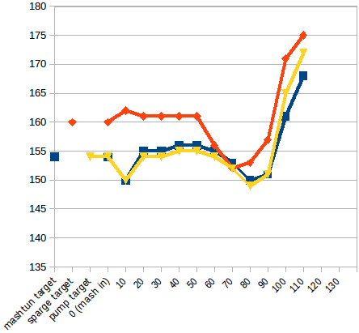
Fire burners: 7:15am
Heat Mash Tun : Target Temp: 154
Heat Sparge Kettle: Target Temp: 160
Target Temp (Mash): 154
Grind grain: 7:45
sparge temp:162
Strike Temp: 154
pump temp: 156
Mash in: 8:07
Temp: 150
Raise/Lower Temp:
Heat On : Heat Off:
Mash: Duration: 90 minutes
Start: 8:07 Finish:9:37
Heat (to deactivate enzymes)
Target Temp: 168 Start: 9:39
Finish: 9:53
Heat Sparge H20 (Target175◦)
Sparge: Start: 9:56
Finish: 10:40
Wort collected: kettle + 15qts
Boil : Burner On: 10:05
Rolling Boil: 10:56
Hops In: 11:04 Hops In: 12:04
Hops in : 12:19
Duration: 90 min Start: 11:04
Finish: 12:34
Burner Off: 12:34
Rest 15 min
Pump and chill:
Start: 12:50 Finish: 1:15
OG : 1.045
Yeast: Nottingham (Lallemand)
Irish Moss

Notes: cooked grated potatoes in spring water to cover, rested maybe 1/2 an hour before mash in
use cara pils next time

